PL/SQL

CREATE TABLE emp1 (

emp_id INT PRIMARY KEY,

emp_name VARCHAR(20),

base_salary INT,

conveyance_fee INT,

tax INT DEFAULT 0,

net_salary INT DEFAULT 0

);

insert into emp1 values(1,'Harsha',25000 , 4000,0,0 );

insert into emp1 values(2,'Vishal',35000 , 3000,0,0 );

insert into emp1 values(3,'Abhilaash',45000 , 2000,0,0 );

select * from emp1;

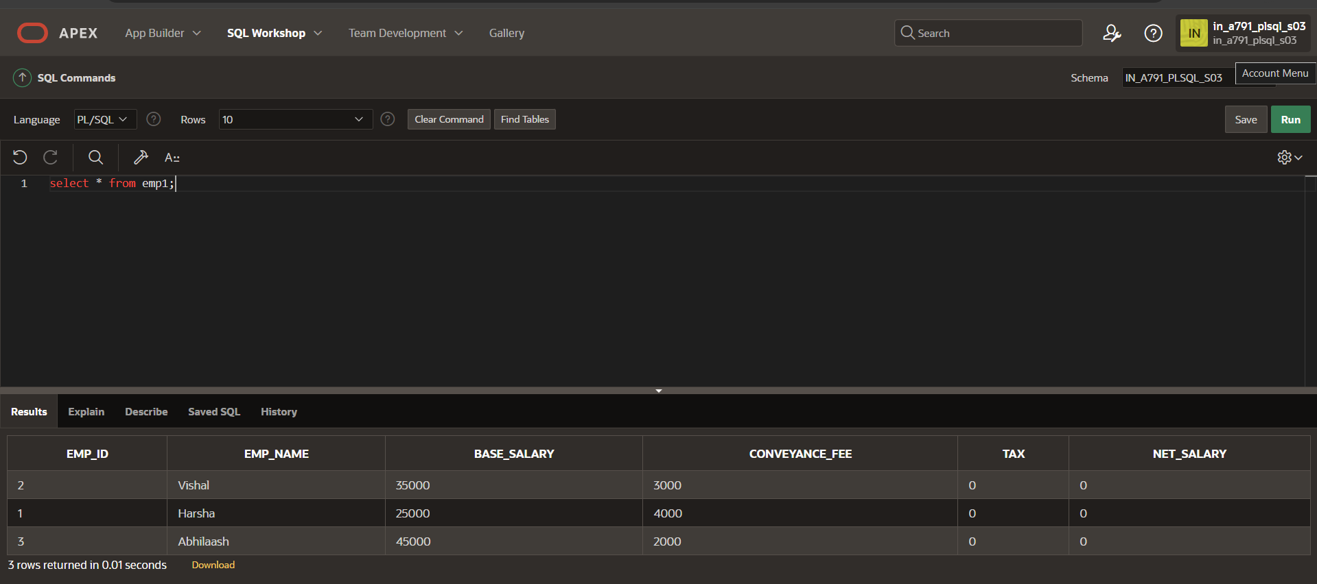

DECLARE

CURSOR cemp IS SELECT emp_id, base_salary FROM emp1;

BEGIN

FOR co IN cemp LOOP

IF co.base_salary <= 30000 THEN

UPDATE emp1

SET tax = 0.1 * base_salary

WHERE emp_id = co.emp_id;

ELSIF co.base_salary > 30000 THEN

UPDATE emp1

SET tax = 0.2 * base_salary

WHERE emp_id = co.emp_id;

END IF;

END LOOP;

UPDATE emp1

SET net_salary =base_salary+conveyance_fee-tax;

END;

/

select * from emp1;

